Student name : Kobilov Ilkhomjon

Student ID : 201923250

**Q1) Signed Numbers**

1) a) -4

b) -3

c) -4

2)

1. 10
2. -101

**Q2) Flip Flops**

1. 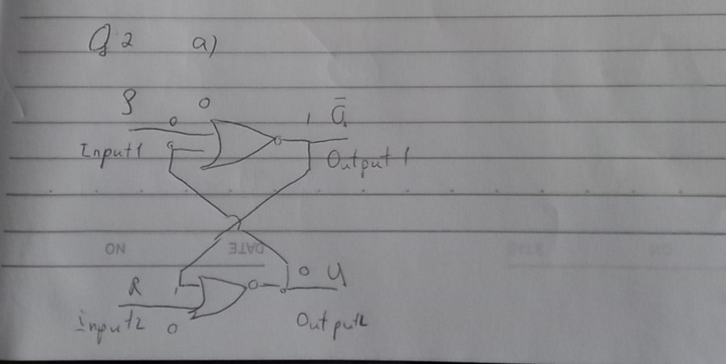

2. Activating the S input sets the circuit, while activating the R input resets it in an S-R latch. The circuit will be faulty if both the S and R inputs are engaged at the same time.

3. First we create the D flip-characteristic flop's table and the S-R flip-excitation flop's table. Then get the boolean expression of S and R in terms of D using the K-map. In the last create a circuit schematic for converting an S-R flip-flop to a D flip-flop.

**Q3) State machine**

a) 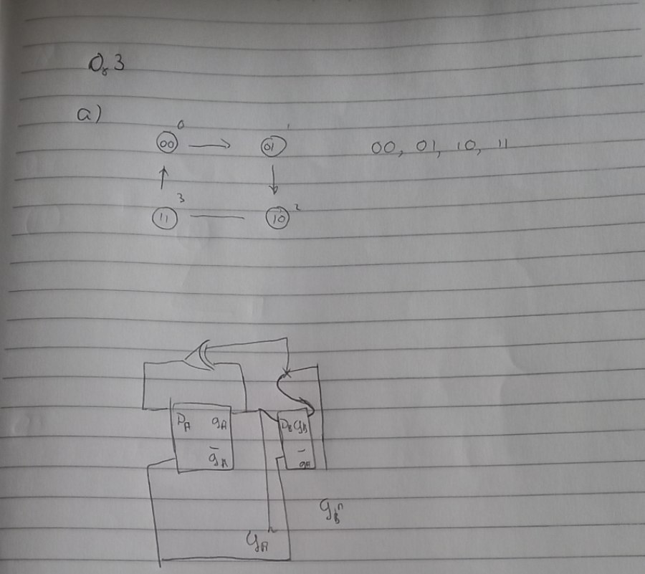

c) Because the number of potential state assignments is too huge, an exhaustive strategy of testing all possible state assignments is not viable.

d) The transformation of a given machine into an equivalent machine with no unnecessary states is known as state reduction.

e) If every state in the first network has an equivalent state in the second network, and vice versa, two consecutive networks are said to be equivalent. Equivalent states are two states in a sequential network are said to be equivalent if their input and output sequences cannot be distinguished.

**Q4) Arduino CTC101, Select the correct answer of the followings:**

1. C
2. B
3. B
4. C
5. A